Greener Fields
Combating Climate Change by Keeping Land in Farming in New York
Communications Toolkit
www.farmland.org/GreenerFields #GreenerFields

Climate change has, and will continue to have, dramatic effects on all New Yorkers – including farmers and citizens concerned about their food and where it comes from. In the future, farming and food production could be significantly impacted by severe weather, including warmer winters with more lake-effect snowstorms; hotter summers with serious droughts; or intense storms with heavy rainfall. At the same time, sea-level rise along our coasts could encroach upon millions of people living along the state’s heavily-populated coastline, displacing residents and pushing new real estate development onto farmland

About the Greener Fields Report
New York State has made a strong commitment to fighting climate change, establishing a goal of reducing statewide greenhouse gas (GHG) emissions by 80 percent by 2050. American Farmland Trust’s Greener Fields report has found that keeping land in farming and promoting good stewardship of the land is an important tool for reducing GHG emissions, as farmland emits approximately 66 times fewer GHGs per acre than developed land in New York.

Connect With Us:
· Learn more at www.farmland.org/GreenerFields
· Like American Farmland Trust | New York on Facebook
· Follow @FarmlandNY on Twitter
· Follow @newyorkfarmland on Instagram
· Use and follow the #GreenerFields hashtag

In this Toolkit:
We developed this toolkit to help partners and people who care about our climate and the future of farming in New York State to communicate the importance of combating climate change by keeping land in farming. We hope you find the following resources helpful! For more information, please contact us at newyork@farmland.org

· Greener Fields Talking Points
· Infographics and Visual Assets
· Sample Tweets
· Sample Facebook Posts

Talking Points

- According to AFT’s Greener Fields report, an acre of farmland emits 66x fewer greenhouse gases than an acre of developed land.
- Keeping land in farming and promoting good stewardship of the land is an important tool for achieving reductions in GHG emissions.
- If the annual rate of farmland loss to real estate development in New York was gradually reduced by 80 percent by 2050, that could reduce the GHG emissions equivalent to taking 1 million cars off the road.

Infographics and Visual Assets
(Right-click to save images)
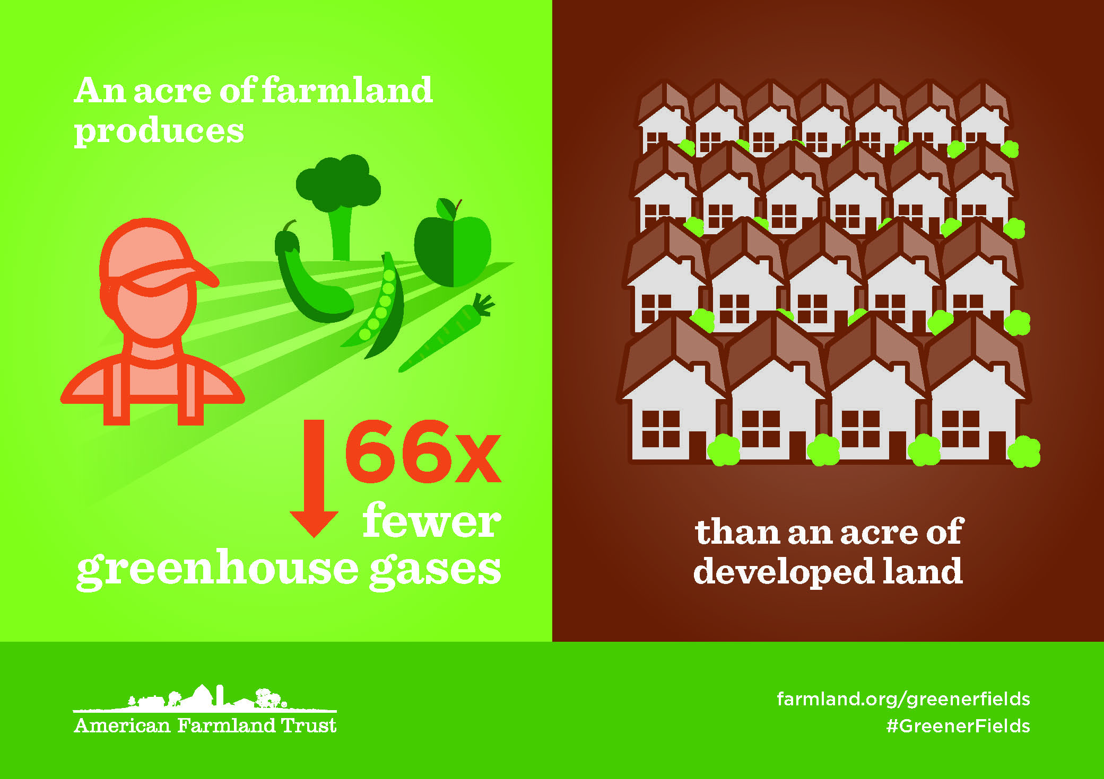

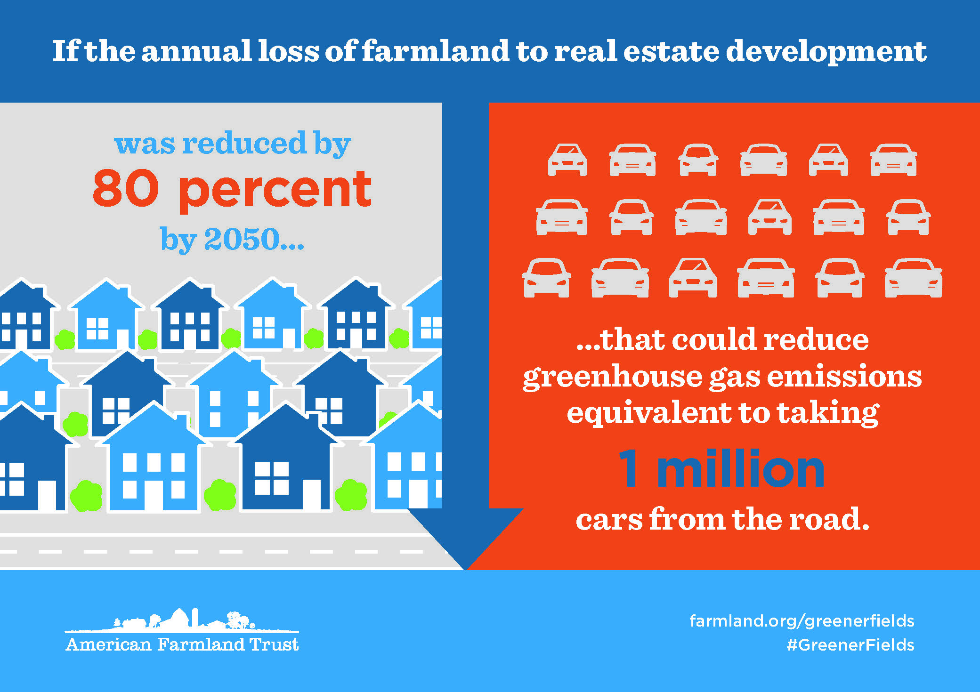
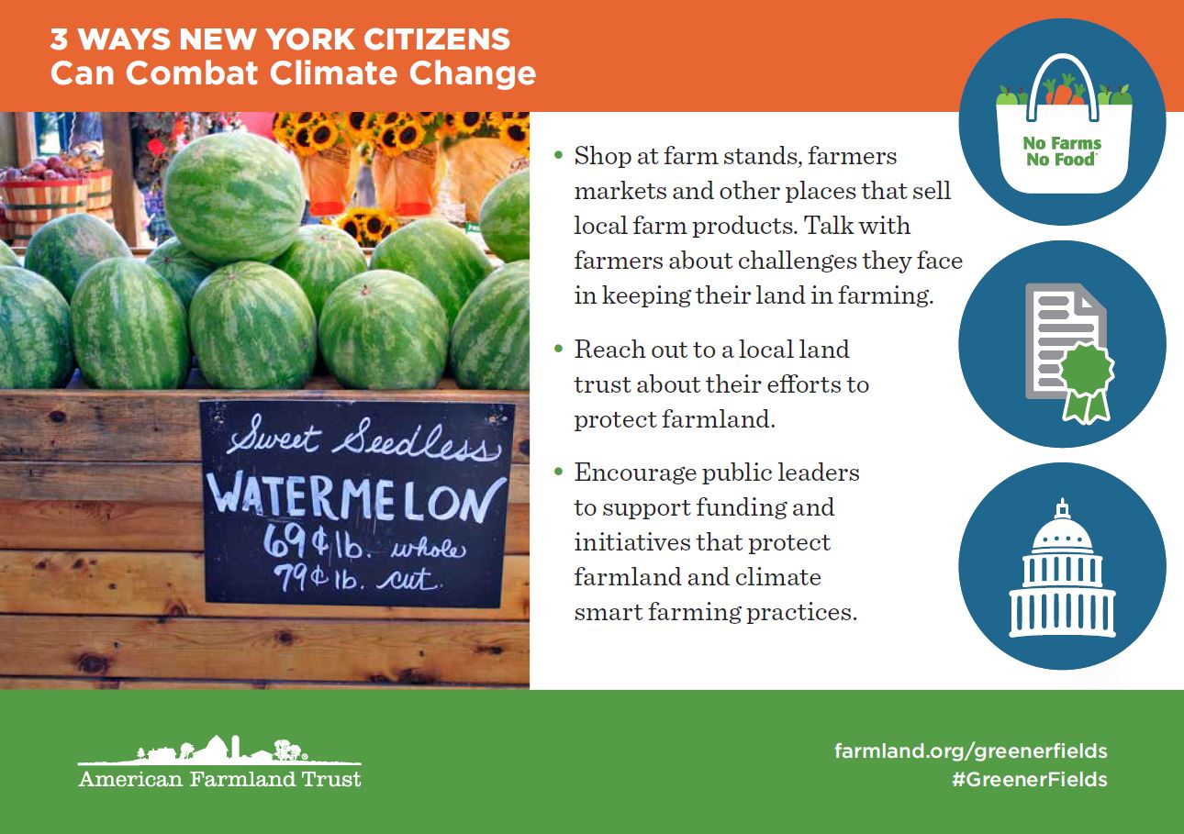

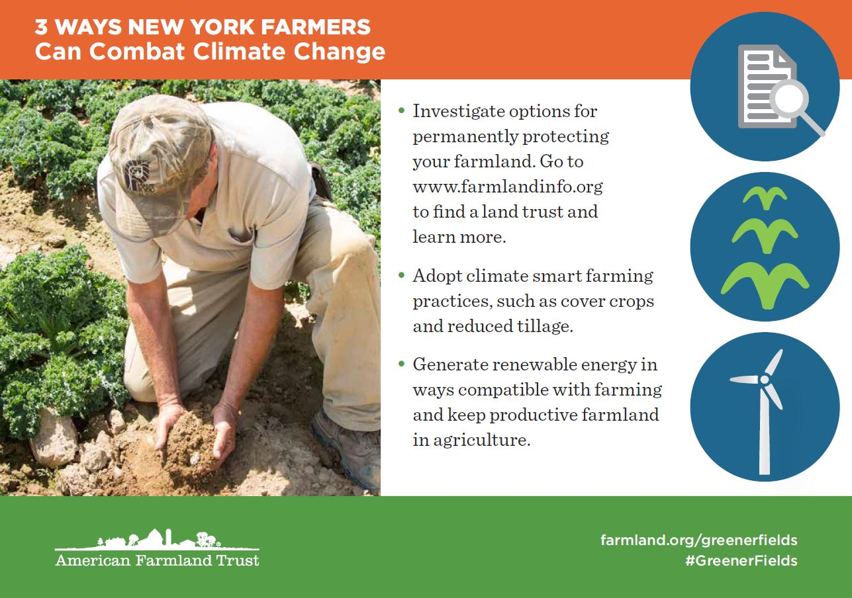
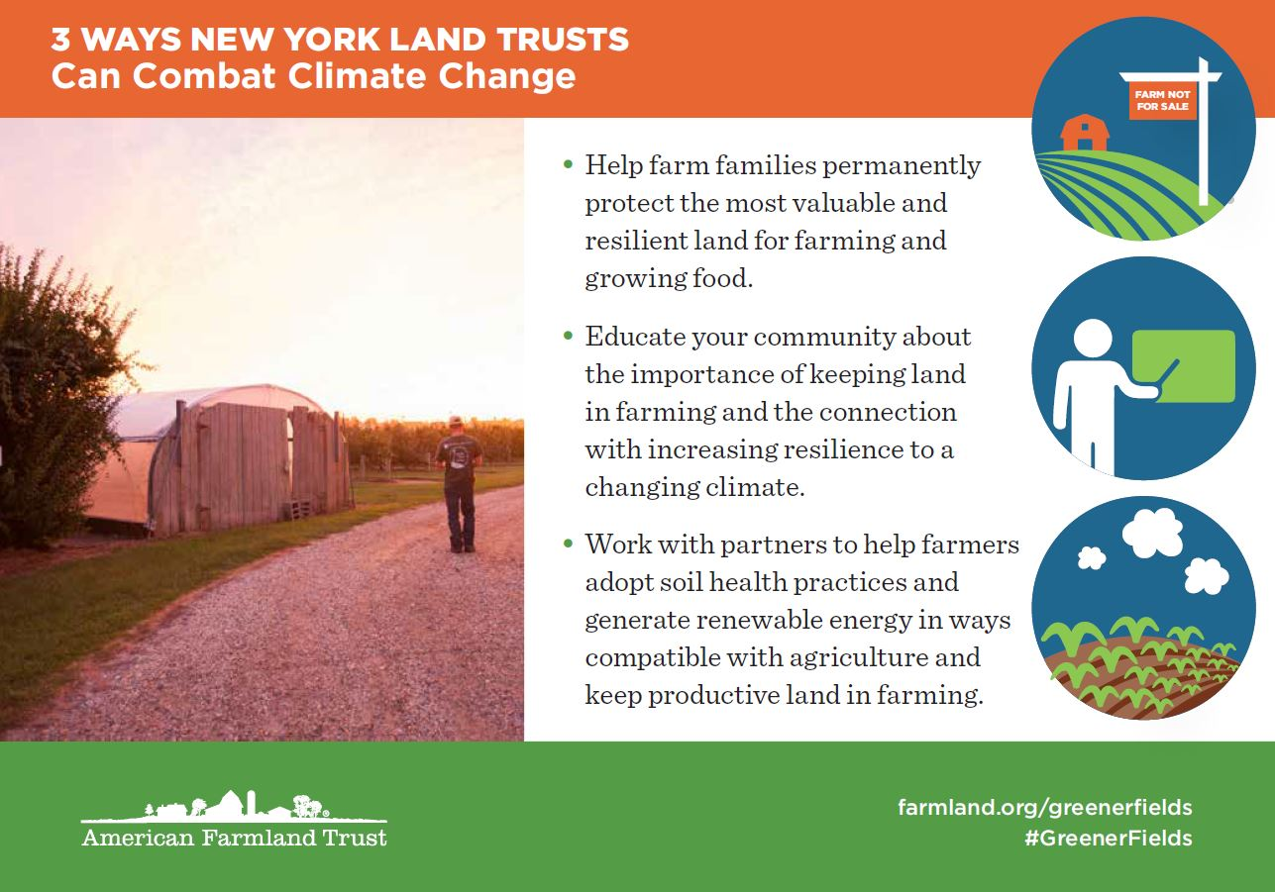

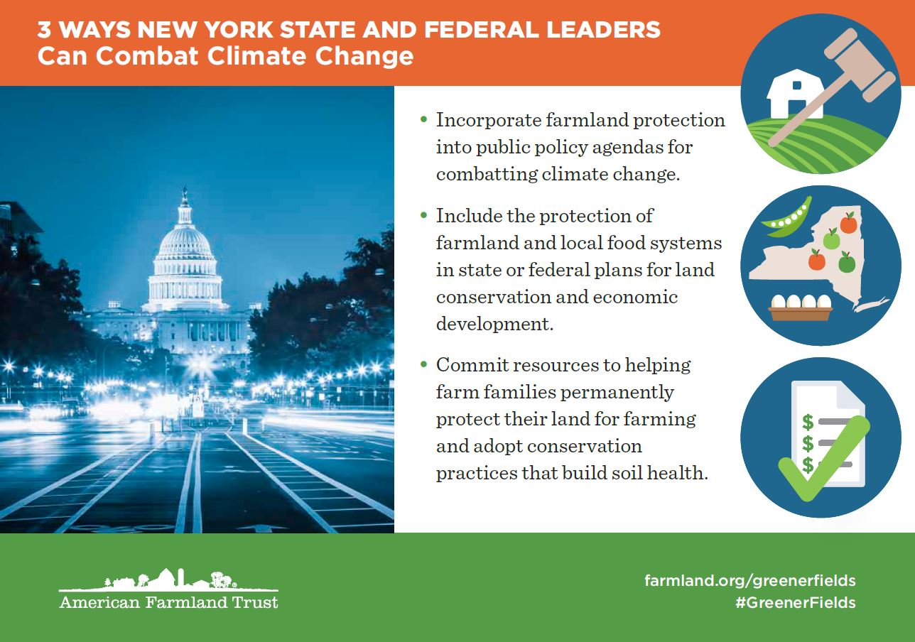
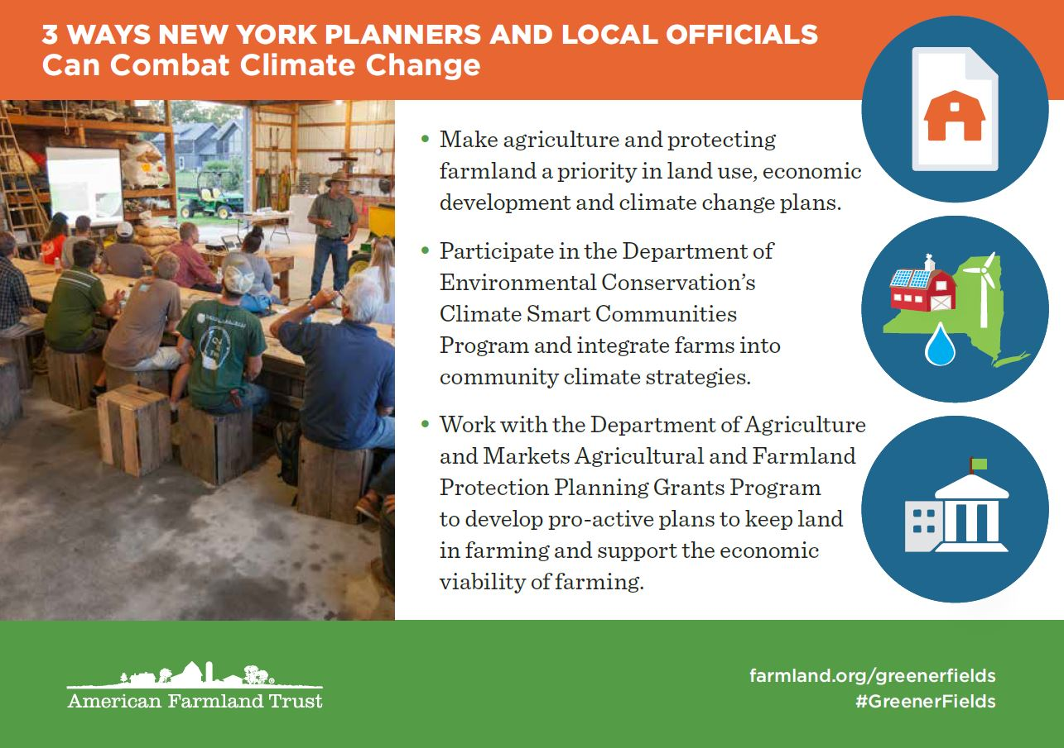

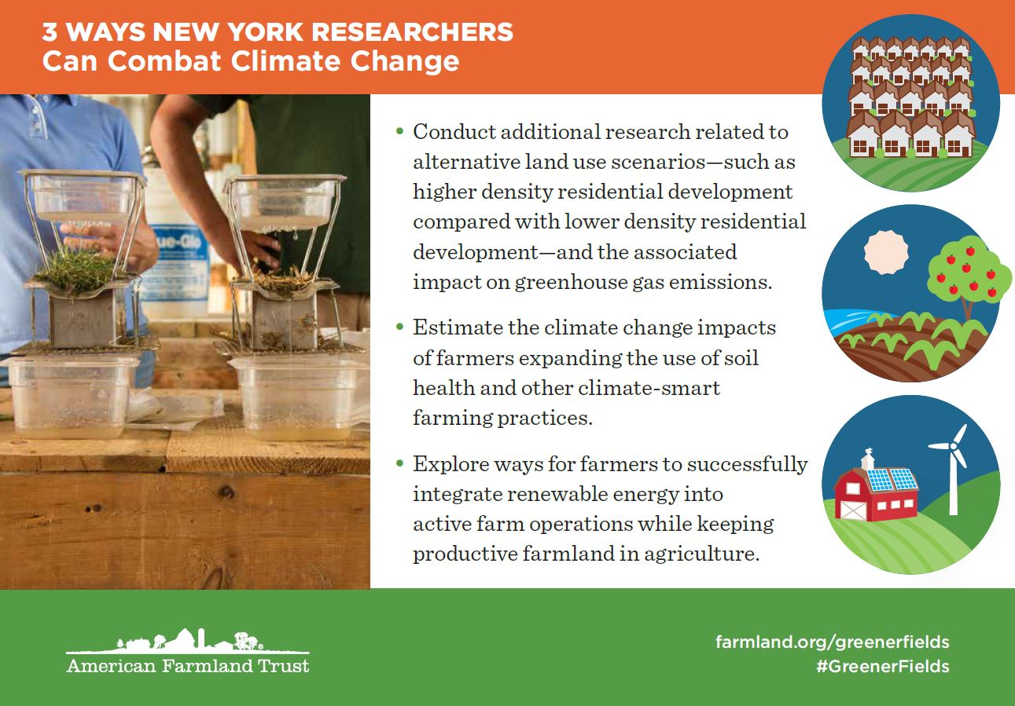
Social Media
When you post about the report or any of its findings or graphics, please make sure to use the #GreenerFields hashtag so we can see it and share! Don’t forget to follow @FarmlandNY on Twitter and like American Farmland Trust New York on Facebook.

Sample Tweets
- @FarmlandNY #GreenerFields report finds an acre of NY farmland produces 66x < greenhouse gasses than developed land www.farmland.org/GreenerFields
- If NY reduced farmland loss by 80% by 2050, it would be equivalent to taking 1M cars off the road. www.farmland.org/greenerfields #GreenerFields
- The #GreenerFields report from @FarmlandNY explains how NY can combat climate change by keeping land in farming. www.farmland.org/greenerfields

Sample Facebook Posts
- Research from @americanfarmlandtrustny finds that an acre of New York farmland produces 66 times less greenhouse gases than developed land. Keeping farmland in production is essential to improving our environment! Learn more at www.farmland.org/GreenerFields #GreenerFields
- If New York could reduce the current rate of farmland loss by 80% by 2050, it would be the eqivalent of taking 1 million cars off the road. www.farmland.org/GreenerFields #GreenerFields

